The current project is split into two major parts - A and B. You will find the instructions for each part separately in the subsequent pages. Let's start with the part A.

Project A Overview
LessonDownloads

Scenario
You have been hired to audit the security for the PC used at your friend’s business: Joe's Auto Body. Joe provides car repair services throughout the area. His previous employees used it for activities unrelated to work (e.g., web browsing, personal email, social media, games, etc.), and he now uses it to store his critical business information. He suspects that others may have broken into it and could be using it to transfer files across the internet. He has asked that you identify threats and vulnerabilities for him according to industry best practices so that it can be again used as a standard PC.
In this project, you have been given a “broken” Windows 10 PC and asked to figure out what’s wrong with it and then make changes to fix and secure it. The process of analyzing and applying security happens in workplaces around the globe and is exactly what cybersecurity professionals do daily. This project allows you to apply what you’ve learned in the course by investigating a Windows 10 PC. The same skills you use on one PC can be applied to thousands.

Use the project template(opens in a new tab) to answer questions and the rubrics at the bottom left, to guide your answers. Your prompts are in the template as well as in the classroom. Images of the "broken" Windows 10 PC are in the classroom only.

Before You Start
Before you start doing the project work, we strongly recommend you look at the rubric in your classroom, against which the human Mentor will review your submission. Your submission must satisfy all rubric criteria to pass the project; otherwise, the Mentor may ask you to re-submit. The rubric is available on the Project Rubric page towards the end of the current lessons.

Advice for students
- This audit is based on instruction throughout the courses thus far. If you get stuck, go back to your notes or that section in the course and review the material.
- It's important that you write each of the steps you take.
- Complete all of the sections in the template.
- There are many security problems with the sample PC. The intent is to challenge you based on what you've learned in this course and what you'll see in real life.
Have fun exploring.

Part A. Windows VM Workspace Instructions
LessonDownloads
For the part A of the current project, you will work the Windows VM Workspace available on the next page. It is a Windows 10 Pro virtual machine. The machine name is JoesGaragePC. We also refer to the workspace as "lab".

Windows VM Workspace - How to Access?
Click on the Access Lab button at the bottom of the current page to load the Windows VM Workspace, and it will take up to 5 mins to boot a Virtual Machine and configure it for the project.

Windows VM Workspace - Terms of Use
- This Windows VM Workspace is a sandbox environment and thus has a limited session duration. After the session expires, the learner will have to reload the lab page and start a new session, which will be counted as the second attempt.
- Udacity does not preserve Azure resources across sessions. After the session expires, any resources you have created (VMs, Databases, Web Apps and their files, etc.) will be deleted.
- There are only 10 attempts permitted for this Windows VM Workspace throughout the course. Therefore, we strongly recommend that learners only access the lab when necessary. After exhausting all attempts, learners will encounter the Usage limit is crossed error, which a learner can resolve by writing an email to "udacity-labsupport@udacity.com(opens in a new tab)".
- Please follow the instructions described in the project instructions. Udacity monitors lab usage to ensure the proper use of resources for educational purposes.
- As Udacity pays for every minute of runtime, please stop the environment when you take a break. Always delete the resources if not in use.
- Misusing the lab resources can cause revoking your lab access or deactivation of your Udacity account.

Getting Help

1. Windows VM Workspace Loading Issues
If you have a problem while loading your Windows VM Workspace, you can send an email, titled Error in Lab, to Udacity Support at (opens in a new tab)udacity-labsupport@udacity.com(opens in a new tab). Please be sure to send your message from the email ID you used to enroll in the Nanodegree program. Please include the following information in your email body:
- Course name
- Lesson name
- Page name
- Steps to replicate the issue
- Error screenshots
Note that the "udacity-labsupport@udacity.com(opens in a new tab)" email is dedicated only to Azure cloud lab support, such as lab loading issues, Azure policy issues, or increasing the retake count. DO NOT email this team for content-related problems. Instead, file a support ticket for content-related issues.

2. Self help resources
- Review the Udacity FAQ(opens in a new tab) - Your question may have already been answered! Search through our FAQ first.
- Submit a question via Knowledge Hub(opens in a new tab) - Knowledge Hub is where you can ask questions specific to the course or Nanodegree you’re enrolled in. This is mainly to get that one on one feedback from mentors in a way similar to the real world using Stack Overflow.

3. Submit a support ticket
If you have a classroom content-related issue blocking your progress, you can submit a support ticket to escalate to the correct Udacity team. You can find the link to file a support ticket(opens in a new tab) in your classroom home.
For other blocking issues, you can write to us at support@udacity.com

Part A.1: Reconnaissance
LessonDownloads

Hardware
The first step in securing any system is to know what it is, what’s on it, what it’s used for, and who uses it. That’s the concept of systems reconnaissance and asset inventory. In this step, you’ll document the hardware, software, user access, system, and security services on the PC. Complete the table on slides 4 to 7 of your template. You can use the Windows VM workspace in the previous page to do so.
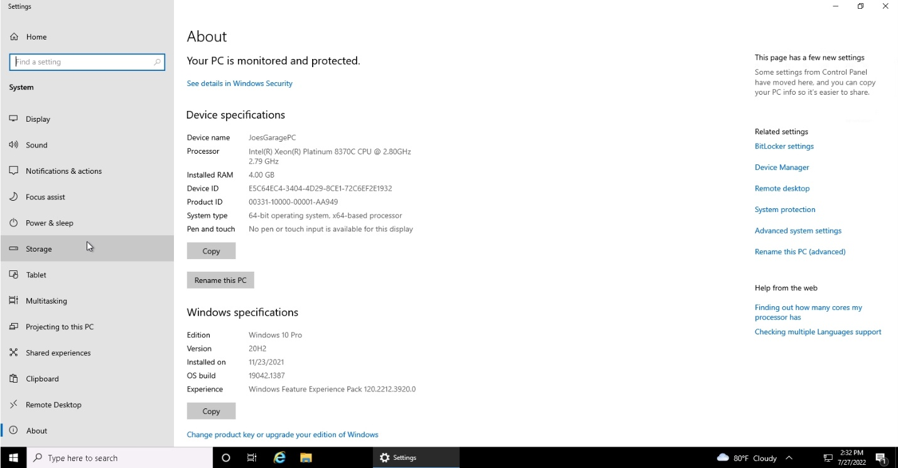

Software
Another common early step in securing is taking an inventory of software or applications installed on a computer system. These are programs outside of the standard operating system. On slide 5 of your template, name 5 installed and running apps on JoesPC.
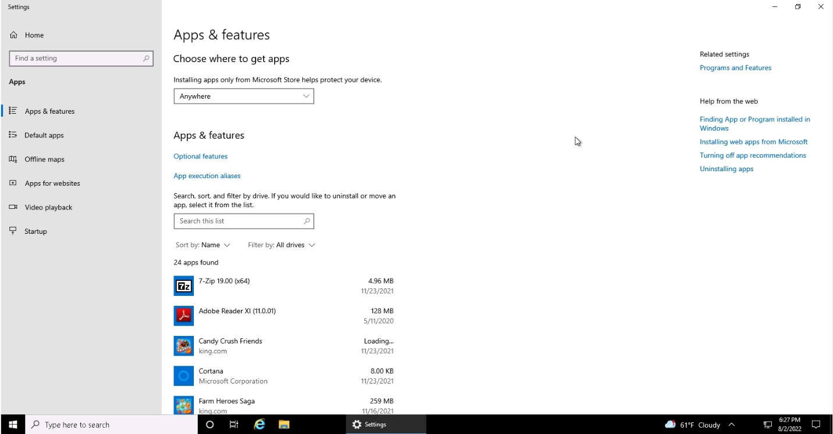
Apps on JoesPC - 1
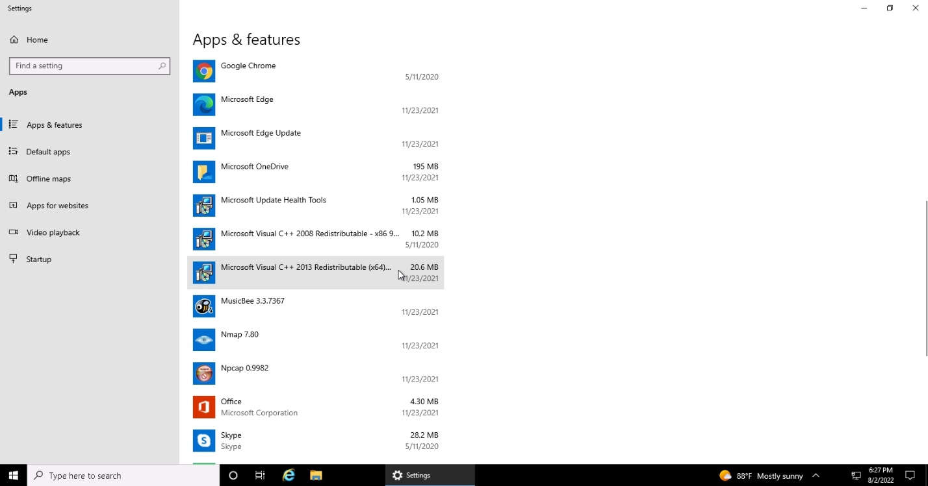
Apps on JoesPC - 2
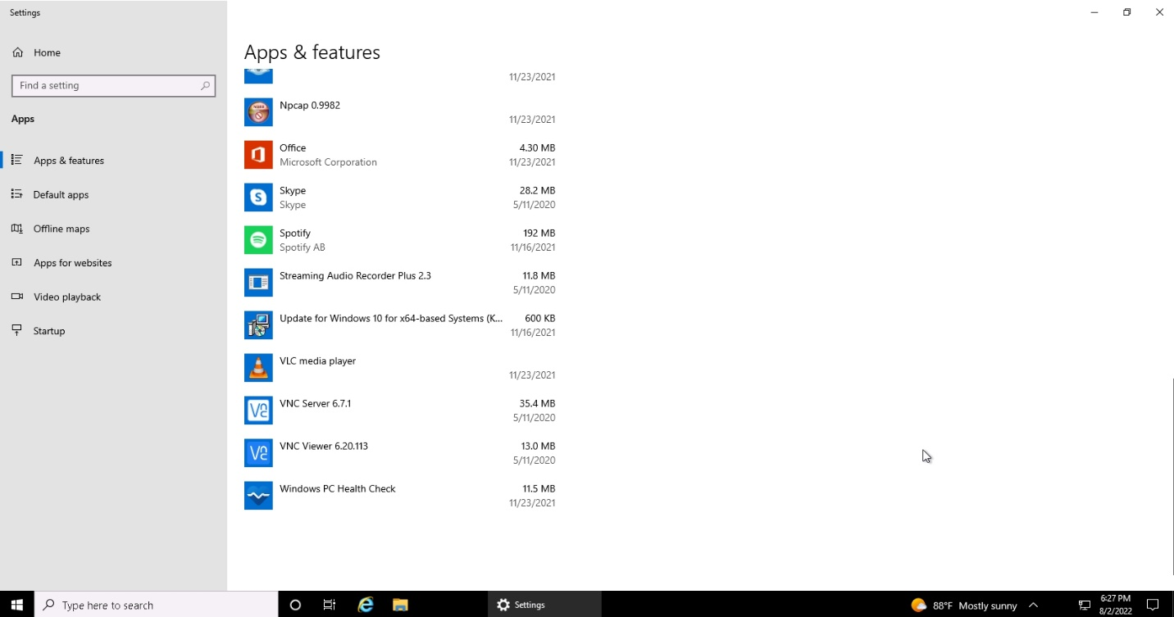
Apps on JoesPC - 3

Accounts
As part of your security assessment, you should know the user accounts that may access the PC. On slide 6 of your template, please list the accounts and the full names.
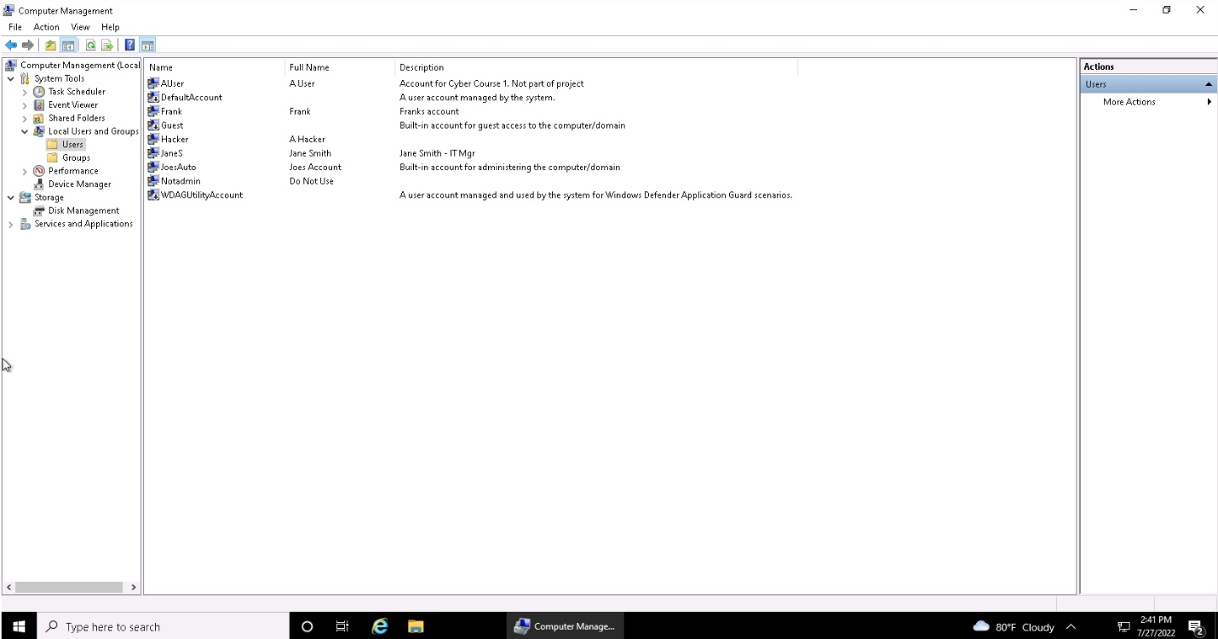
Accounts on JoesPC

Access level of the accounts
Continuing with the security assessments on accounts, on Slide 6, mention the access levels (Administrator or Not) for the accounts on this PC.

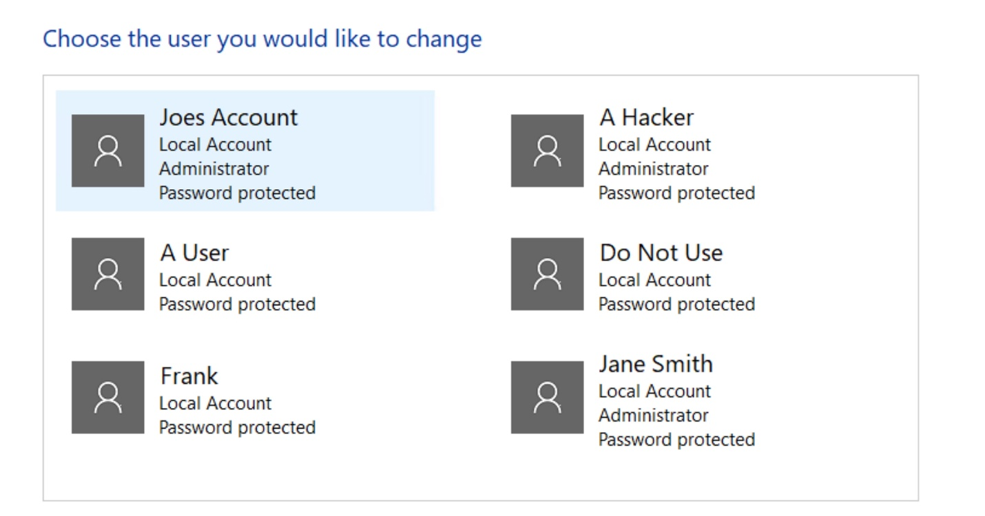
Access levels of Accounts on JoesPC

Security Services
Use the screenshots below to document the PC’s security settings status on slide 7 of your template.
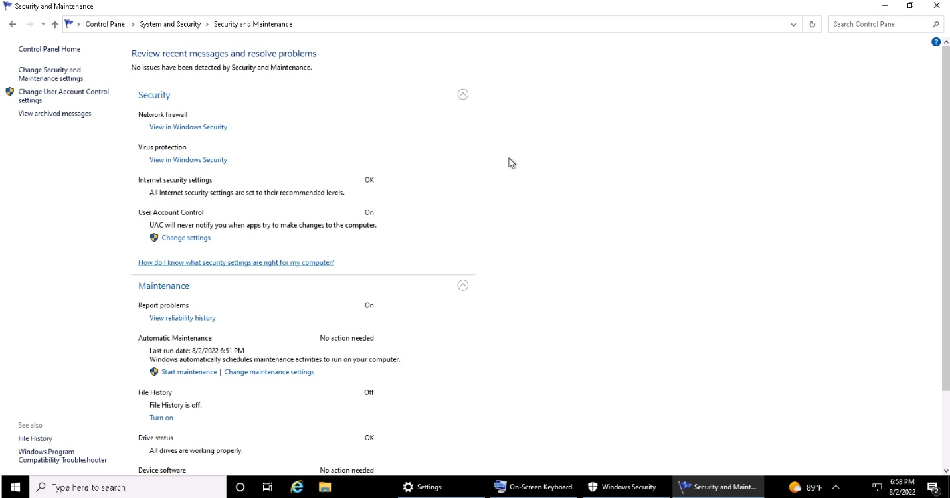
Security & Maintenance Overview
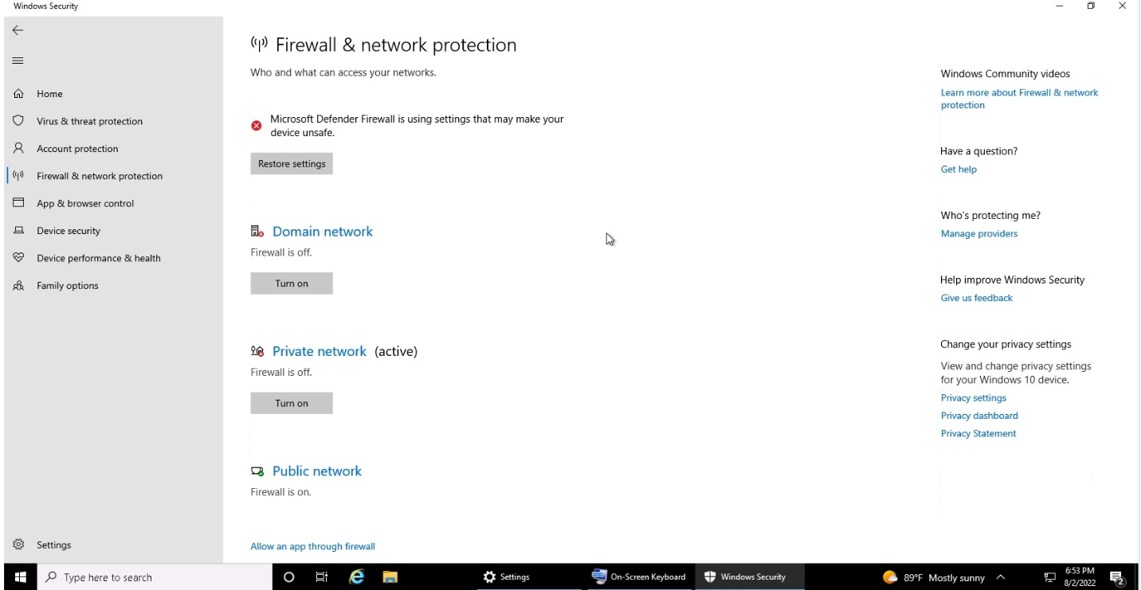
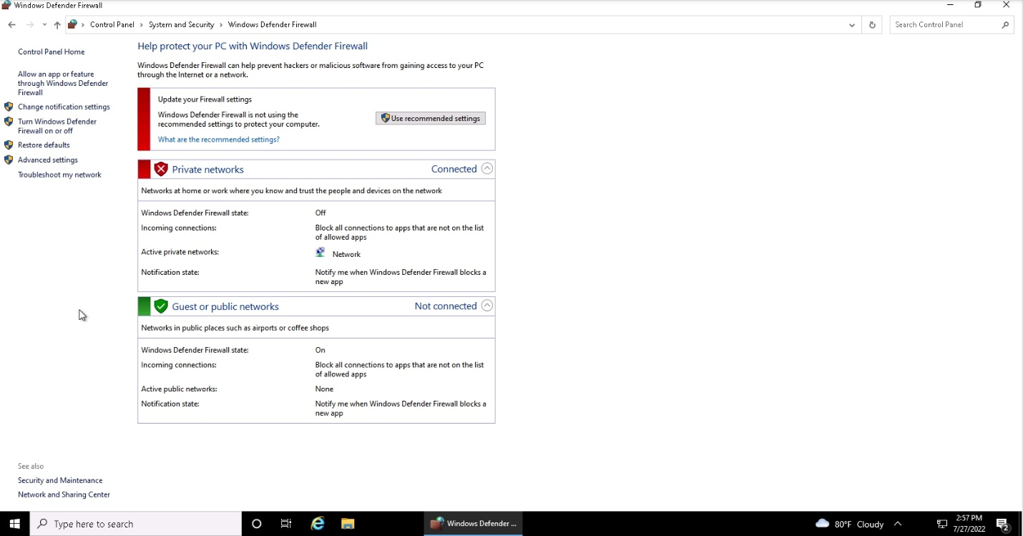
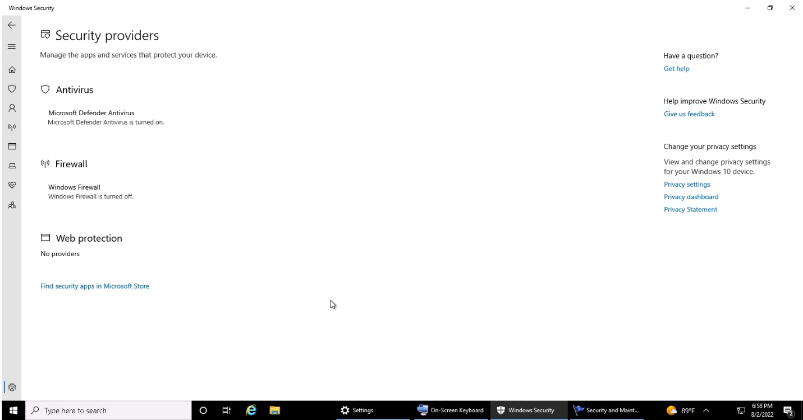
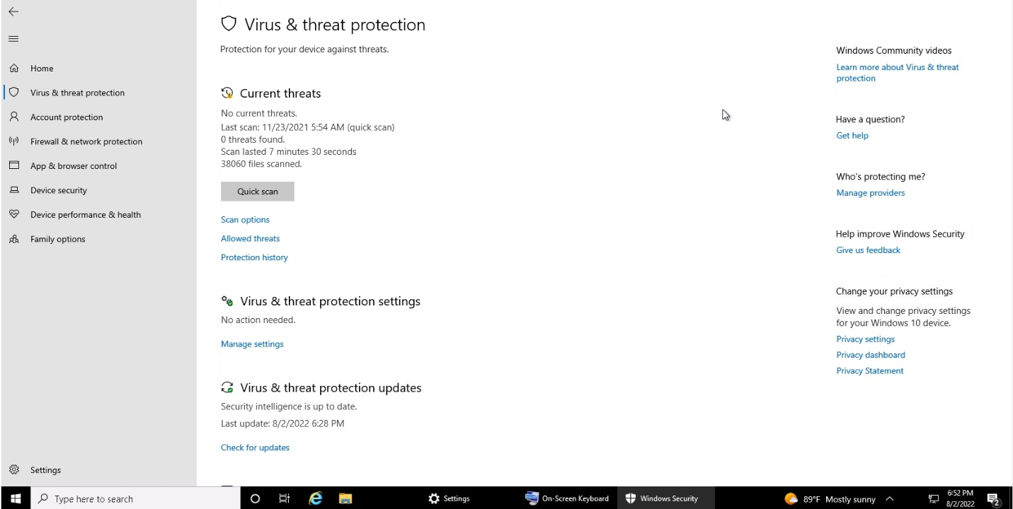
Virus & Threat Protection

Part A.2: Assessment
LessonDownloads

Authentication
Consider the 3 factors of authentication: something you KNOW, something you HAVE, and something you ARE. On slide 9 of your template, in 1 to 3 sentences, suggest and explain what type of authentication would be appropriate for the Windows machine in the workspace.

System and Security: Firewall
In 1 to 2 sentences, explain what protection would enabling a firewall provide on slide 10 of your template.

System and Security: Virus and Threat Protection
You must ensure the Windows Defender anti-virus software is enabled to protect against current threats. It should be set to scan the PC for malicious software automatically continually. Answer the following prompts on slide 11 of your template.
- In 1 to 2 sentences, explain what protection enabling the Microsoft Defender Antivirus would provide.

Part A.3: Securing Access
LessonDownloads

Scenario
Ensuring only specific people have access to a computer is a common step in information security. It starts by understanding who should have access and the rules or policies that should be followed. Please review the following users who should have access.
- JoesAuto
- Jane Smith (Joe’s Assistant)
It is your responsibility to create suggestions for securing this computer. Use the following information to give and explain your recommendations.
On slide 14 of your template, please provide recommendations for the following:
- How should they authenticate their identity?
- What Access Rights/Permissions should Joe have?
- What Access Rights/Permissions should Jane have?
On slide 15 of your template, please answer the following questions:
- In 1 to 2 sentences, explain why it is important to disable or remove unneeded accounts from a PC or application.
- Administrator privileges for too many users is a security challenge. Provide at least 3 risks associated with users having administrator rights on a PC.

Part A.4: Securing Applications
LessonDownloads

Unnecessary Applications
Joe wants everyone to use the latest version of the Chrome browser by default. There should be no games or non-work-related applications installed or downloaded. Joe is also concerned that there are “hacking” programs downloaded or installed on the PC that should be removed. This PC is used for standard office functions. Please reference the screenshot below and answer the questions on slide 17 of your template, also listed below.
- List three applications that violate this policy.
- Name three vulnerabilities, threats, or risks to having unnecessary applications.

Applications on JoesPC - 1

Applications on JoesPC - 2

Applications on JoesPC - 3

Patching and Updates
All applications should be up-to-date on patches or fixes by the manufacturer. Any old version of software should be uninstalled. On slide 18 of your template, list two applications on Joe’s PC that are out of date.

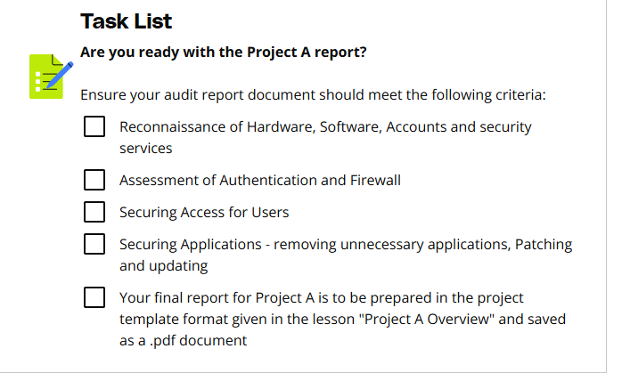

Project B Overview
LessonDownloads

Project Overview
Suppose that you work for an organization and your manager asked you to develop a set of integrated tools that perform a set of cybersecurity services and evaluations for the organization.
The required cybersecurity services include the following. It is your responsibility to implement at least three of the following services to fulfill all the project requirements.
- B1. Generate secure passwords for the organization's employees
- B2. Evaluate the strength of any previous passwords selected by the employees currently working in the organization
- B3. Apply confidentiality to data stored in selected organizational files
- B4. Confirm the integrity of data stored in selected organizational files when these files are transferred between employees.
You can use Python language to develop this part B of the project.

Submission Artifacts
Here are the list of files you will submit as part of this project.
.
├── README.md
├── Part_A
│ └── report.pdf
└── Part_B
├── B1_program.py
├── B2_program.py
├── B3_program.py
├── B4_program.py
├── data.txt
├── decrypted.txt
├── encrypted.txt
├── hashes.txt
├── input.txt
└── rules.txt

VS code for Python workspace Introduction
LessonDownloads
Below is the screenshot of the VS Code workspace highlighting the different sections in the workspace. You will use this VS Code workspace to write your Python code.
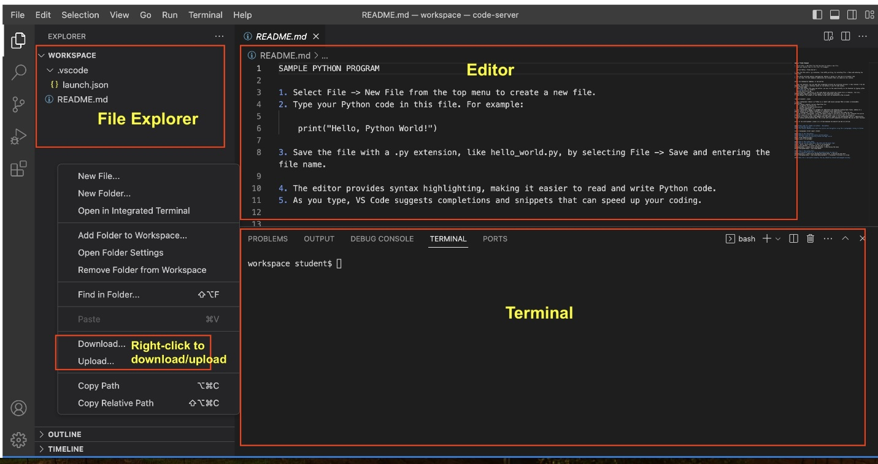
A screenshot of the VS Code workspace highlighting the different sections in the workspace
Here are the main sections in the VS Code workspace:
- Editor: This is the large central part of the screen where you write your Python code. It's like using a text editor but with special features. VS Code highlights Python syntax, like keywords and strings, in different colors to make it easier to read and understand your code.
- File Explorer: On the left side, there's a panel called the File Explorer. It shows all the files and folders in your project.
- Terminal: At the bottom of the screen, there's a section for the terminal or command prompt. You can run your Python scripts directly from here.
- Lastly, if you want to download some files to your local or upload them to the workspace, you can right-click in the file-explorer area and select the Download or Upload option.
One of the good things about this VS Code workspace is that Udacity will preserve your progress. If you plan to finish this project in portions and return later to finish this remaining project, you will get your files from the last session in the workspace.
Now, here is your turn to load the VS Code worksapce below and experience it yourself.

Part B.1: Secure Password Generator
LessonDownloads

Context
The manager of your organization has asked you to develop a tool that enables the employees of the organization to generate strong secure password based on some rules.

ToDo
Open the VS Code workspace below, and do the following:
- Create a text file rules.txt, and mention at least three rules (criteria) to create a strong/secure password.
  - For example, you can think of rules related to password length, choice of characters, etc.
  - Provide two example passwords, so the employees of your organization will understand the rules better.
- Write a Python program in the file B1_program.py to generate a secure password per the rules you have suggested in the text file above. The program should display the generated password on the terminal. Each time you run the program, it will generate and display a new password on the terminal.
The README.md file in the workspace below will provide you with some guidance around creating files and running a Python program.
Deliverables for this section are:
- rules.txt
- B1_program.py

Part B.2: Password Security Strength Evaluator
LessonDownloads

Context
The manager of your organization has asked you to develop a tool that provides an evaluation service to any employee of the organization to check the security strength of his old password.

ToDo
Write a Python program in the file B2_program.py to evaluate a given password for its security strength. The workspace below already has the file template ready for you.
The program should do the following:
- Ask for a password from the user in the Terminal, as shown in the code block below:
- ## Terminal
Enter the password string you want to evaluate:
- Evaluate the given password against the three or more rules (criteria) you have already defined in the B1 section earlier.
- Print "Compliant" if the password meets all the rules (criteria). Here is an example output in case of a compliant password:
- ## Output
Compliant.
- Otherwise, print "Non-compliant", and also print the specific rule that did not pass. Here is an example output in case of a non-compliant password:
- ## Output
- Non-compliant.
- The given password did not pass the following criteria:
- Password should have at least eight characters.
In your case, the criteria can be different. Don't forget to evaluate the given password againt all three or more rules (criteria) you have already defined in the B1 section earlier.
Deliverables for this section are:
- B2_program.py

Part B.3: Data Confidentiality Application
LessonDownloads

Context
The manager of your organization has asked you to develop a tool that provides an encryption/decryption service that is required to be applied to the data stored in the selected files of the organization.
- Encryption: The encryption service will read the plain text from a text file as an input, convert the plaintext to ciphertext.
- Decryption: The decrytion service will read an encrypted file and generate the decrypted file.

ToDo
Write a Python program in the file B3_program.py to encrypt and decrypt a given plaintext file using the Ceaser cipher algorithm. The workspace below already has the file template ready for you.
The program should define the following functions:
- caesar_cipher(text, shift) function - In this function, the text is plain text, and the shift is a numeric value by default set to 3. The function will encrypt the plaintext by shifting the characters right by shift positions. The input.txt file is present in the workspace.
- caesar_decipher(text, shift) function - In this function, the text is the ciphertext, and the shift is a numeric value by default set to 3. The function will decrypt the ciphertext by shifting the characters left by shift positions.
In summary, you will read the plaintext from an input.txt file, and generate the encrypted text and save it into the encrypted.txt. Next, you will read the encryped text and generate the decrypted text and save it into the decrypted.txt file.
Did you noticed that the content of the input.txt and decrypted.txt files will be the same?
Deliverables for this section are:
- B3_program.py
- input.txt
- decrypted.txt
- encrypted.txt

Part B.4: Data Integrity Application
LessonDownloads

Context
The manager of your organization has asked you to develop a tool that provides a service to guarantee the integrity of the data stored in the files of the organization while transferring these files on the organization network.
The required tool should provide a service that generates the hash value of an input text file using the MD5 hashing algorithm. If anyone changes the file content, the hash value will also change. This is how you check for the integrity of a given file.

ToDo
- You find the data.txt file in the workspace below. Use the MD5 command-line utility to check the hash for the given file. Note down this original hash value in a test file hashes.txt.
md5sum <file-name>
- Make any edit in the data.txt file, and check the hash again. Note down the new hash value again in the hashes.txt.
- Now that you know the hash value, finish the given Python program in the B4_program.py file to generate the MD5 hash for the data.txt file. The given program uses the hashlib(opens in a new tab) Python package that already has built-in function available calculate MD5 hash. You need to write only one line of code marked as ToDo to finish the given Python program. When you run the program to calculate the MD5 hash, note the output again in the hashes.txt.
Deliverables for this section are:
- B4_program.py
- data.txt
- hashes.txt

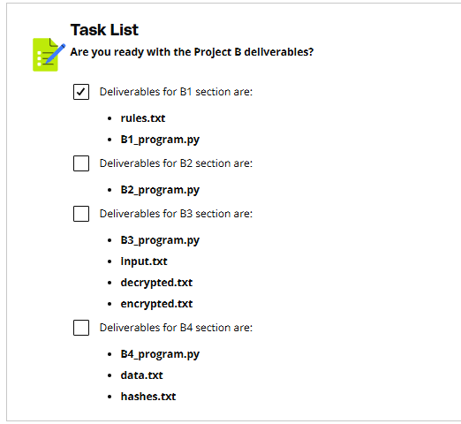

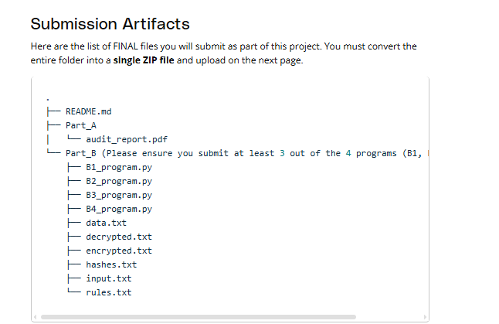
Rubric
Use this project rubric to understand and assess the project criteria.

Reconaissance
Criteria | Submission Requirements
Identify a computer's hardware specifications | The device name, processor, installed RAM, System Type, Windows Edition, Version, OS build, and installation information of Joe's PC are correctly identified.
Identify applications running on a computer | The names of 5 applications running on Joe's PC are correctly identified.
Identify all of the user accounts on a computer | The account name, full name, and access level for each user on Joe's PC is documented.
Document the status Security Services running on a computer | The status of each security feature is correctly documented:  - firewall product (both private and public network)  - virus protection  - internet security messages  - network firewall messages  - virus protection messages  - user account control settings.

Assessment
Criteria | Submission Requirements
Propose a factor of authentication to secure a device | An authentication factor is suggested for Joe's PC. The suggestion is supported with a 1-3 sentence justification.
Identify the benefits of Windows Firewall | The benefits of enabling the Windows Firewall on Joe's PC are explained in 1-2 sentences.
Identify the benefits of Microsoft Defender Antivirus | The protection provided by enabling the Microsoft Defender Antivirus is explained in 1-2 sentences.

Securing Access
Criteria | Submission Requirements
Recommend appropriate authentication and rights per user | Authentication requirements are recommended for all users.  Permissions are recommended for Joe and Jane.  A 1-2 sentence explanation is given for each recommendation.
Explain the importance of limiting users. | The importance of disabling unneeded accounts from a PC or application is explained in 1-2 sentences.
Explain the importance of least privilege | Three risks of users having administrator rights on a PC are listed.

Securing Applications
Criteria | Submission Requirements
Analyze potential violations, vulnerabilities, threats, and risks caused by unnecessary applications. | Three applications on Joe's PC that violate the "no games or non-work-related" applications rule are identified.  Three potential vulnerabilities, threats, or risks to having unnecessary applications are identified.
Evaluate applications for out-of-date software | Two outdated applications on Joe's PC are identified.

Secure Password Generator
Criteria | Submission Requirements
Propose rules for secure password generation. | The rules.txt text file contains a list of at least three rules that govern the formation of any newly generated secure password.  Provide two example passwords in the text file.
Write a Python program to generate a secure password | The B1_program.py Python program generates a secure password per the rules you have suggested in the text file above.  - The program should display the generated password on the terminal.  - Each time you run the program, it generates and displays a new password on the terminal.

Password Security Strength Evaluator
Criteria | Submission Requirements
Write a Python program to evaluate and share the security strength of a password | The B2_program.py program evaluates a given password for its security strength.  - Asks the user to input a password string.  - Prints "Compliant" if the password meets all the rules (criteria).  - Prints "Non-compliant" if the password meets all the rules (criteria) and prints the specific rule that did not pass.

Data Confidentiality application
Criteria | Submission Requirements
Write a Python program to implement the Ceaser cipher algorithm. | The B3_program.py encrypts and decrypts a given plaintext file using the Ceaser cipher algorithm.  - Encryption logic is coded in the caesar_cipher(text, shift) function. The output is saved  - Decryption logic is coded in the caesar_decipher(text, shift) function.

Data Integrity application
Criteria | Submission Requirements
Create a Python program that implements the MD5 hashing algorithm for integrity checks. | The B4_program.py file generates the MD5 hash for the data.txt file. The resulting hash is saved in the hashes.txt file either manually or by the Python program.

Suggestions to Make Your Project Stand Out
- Joe has decided to allow least privilege access to 2 additional employees. He would like the bookkeeper and the head mechanic to have access to Joe's PC. Use 3 - 5 sentences to describe the privileges these two employees should have, and detail how they should authenticate their identities.
- Joe believes one of his employee’s emails has been compromised. What are the possible threats, risks, or vulnerabilities, and how should he respond? Detail your answer in 3 to 5 sentences.

